**Hospital Management System**

This Hospital Management System Database Design has an **ER Diagram for Hospital Management System project**. This material includes **database schema**, **Data dictionaries**, **Database Tables**and **ERD.**

**1. What is Hospital Management System Database Design?**

The Hospital management system database design is a database design use for managing **hospital** functions and events. It enables the admin to register a patient for the hospital, stores their disease details into the database. Any of the staff members, doctor & admin is able to add, view, edit, update or delete data.

**2. What is the purpose of Hospital management System database?**

The purpose of the Hospital Management system database Design is to make a secure and easy way of storing information of the patient, doctors, inpatient, outpatient, Rooms, and Bill payment.

**3. What are the Features of the Hospital Management System Database Design?**

There are seven common features of Hospital Management System Database Design such as Managing Patients, Doctors, laboratory, Inpatient, Outpatient, Rooms, and Hospital Bills information.

**ER DIAGRAM FOR HOSPITAL MANAGEMENT SYSTEM**

* **Manage Patients**

This table of ER Diagram Hospital Management System will be used for storing and managing the patient information.

* **Manage Doctor**

This table will be used for storing and managing the Doctor information and login account.

* **Manage Laboratory**

This table will be used for storing and managing the Laboratory transaction.

* **Manage Inpatient**

This table will be used for storing and managing the inpatient information and diagnosis.

* **Manage Outpatient**

This table will be used for storing and managing the inpatient information and diagnosis.

* **Manage Room**

This table will be used for storing and managing the room information and assigning of patient in every room.

* **Manage Bills**

The billing table will be used for managing the statement of accounts per patient and for the collection of bills.

**Diagram for the Hospital Management system**

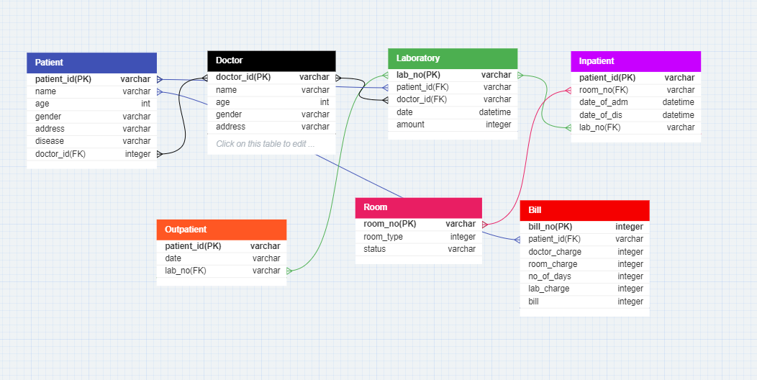

**This ER** **diagram for hospital management system with relationship** shows the entity of the proposed SCA Hospital Management system database, which is presented by tables; the tables are made to meet the required specification of the system and provide much more specific details of each entity within the system.

**Table 1: tblPatient**

|  |  |  |  |
| --- | --- | --- | --- |
| **Field Name** | **Description** | **Type** | **Length** |
| patient_id (PK) | Patient ID | varchar | 10 |
| name | Patient Name | varchar | 50 |
| age | Patient Age | int | 3 |
| gender | Patient Gender | varchar | 50 |
| address | Patient Address | varchar | 50 |
| disease | Patient Disease | varchar | 50 |
| doctor_id(FK) | Doctor ID | varchar | 20 |

**Table 2: tblDoctor**

|  |  |  |  |
| --- | --- | --- | --- |
| **Field Name** | **Description** | **Type** | **Length** |
| doctor_id(PK) | Doctor ID | varchar | 10 |
| name | DoctorName | varchar | 30 |
| age | Doctor Age | int | 3 |
| gender | Doctor gender | varchar | 50 |
| address | Doctor address | varchar | 50 |

**Table 3: tblLaboratory**

|  |  |  |  |
| --- | --- | --- | --- |
| **Field Name** | **Description** | **Type** | **Length** |
| lab_no(PK) | Laboratory Number | varchar | 10 |
| patient_id(FK) | Patient Id | varchar | 10 |
| doctor_id(FK) | Laboratory Date | varchar | 10 |
| date | Laboratory Date | Date / Time | 10 |
| amount | Amount of lab | int | 20 |

**Table 4: tblInpatient**

|  |  |  |  |
| --- | --- | --- | --- |
| **Field Name** | **Description** | **Type** | **Length** |
| patient_id(PK) | Patient id | varchar | 10 |
| room_no(FK) | Room number | varchar | 50 |
| date_of_adm | Date of admission | Date/time | 10 |
| date_of_dis | Date of discharge | Date/time | 10 |
| lab_no(FK) | Laboratory Number | Varchar | 10 |

**Table 5: tblOutpatient**

|  |  |  |  |
| --- | --- | --- | --- |
| **Field Name** | **Description** | **Type** | **Length** |
| Patient_id(PK) | Patient ID | varchar | 10 |
| date | Date of Outpatient | varchar | 10 |
| lab_no(FK) | Laboratory Number | varchar | 20 |

**Table 6: tblRoom**

|  |  |  |  |
| --- | --- | --- | --- |
| **Field name** | **Description** | **Type** | **Length** |
| room_no(PK) | Room number | varchar | 50 |
| room_type | Room Type | varchar | 50 |
| status | Status Of Room | varchar | 20 |

**Table 7: tblBill**

|  |  |  |  |
| --- | --- | --- | --- |
| **Field Name** | **Description** | **Type** | **Length** |
| bill_no(PK) | Patient Id | int | 11 |
| patient id(FK) | Patient name | varchar | 10 |
| doctor_charge | Patient age | int | 10 |
| room_charge | Patient gender | int | 10 |
| no_of_days | Patient address | int | 10 |
| lab_charge | Patient disease | int | 10 |
| bill | Doctor id | int | 10 |

**Conclusion**

This Hospital system database design is a requirement in the dbms mini project.